https://click.em.pge.com/?qs=43d41189d048e5daeef06a2fde315c2e24e611cf22b13b48ac6358884dd98ae56a8b5b363b17d5b771c652efe64a2cbceff5df245230982fe788300a68cf9e68

Join us for a virtual town hall to learn more about what we are doing to reduce wildfire risk and better serve you and your community.

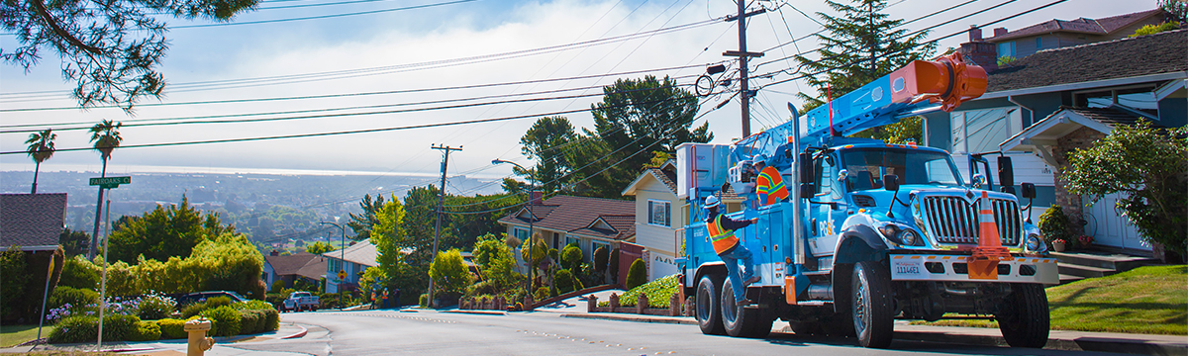

PG&E Virtual Town Hall
South Bay & Central Coast
Monterey, San Benito, San Luis Obispo, Santa Barbara, Santa Clara and Santa Cruz Counties

Tuesday, March 11 | 5:30 - 6:30 p.m.

Join webinar »

Call 888-972-7809 »

Conference ID: 3788384

We’ll share how we are working to better serve you and your community by reducing wildfire risk. Attendees will have the opportunity to ask questions and connect with PG&E leaders, including Regional Vice President, Teresa Alvarado.
We encourage you to join and learn more about:
• | Regional updates
• | Wildfire safety work happening in your area
• | Tips and resources to keep you safe

For more information on how you and your family can plan for and stay safe during an emergency, please visit safetyactioncenter.pge.com »

View this webinar and past recordings »

Add this virtual event to your calendar

  |  

English closed captions and American Sign Language will be available. Please reach out to webinars@pge.com if you need an ADA reasonable accommodation to attend this meeting. Los subtítulos en español estarán disponibles. 將提供中文字幕。For translation support in 240+ languages, call PG&E 1-866-743-6589. To request communications in large print or braille, call 1-800-743-5000.

 |  |  |  | 


pge.com | | Privacy | | Disclosure | | Unsubscribe | | View as a web page

Following the wildfires in 2017 and 2018, some of the changes included in this email are contemplated as additional precautionary measures intended to further reduce future wildfire risk.
For inquiries, please do not reply to this email. Contact Us for more information. "PG&E" refers to Pacific Gas and Electric Company, a subsidiary of PG&E Corporation.
300 Lakeside Dr. Oakland, CA 94612
© 2025 ​Pacific Gas and Electric Company. All rights reserved. These offerings are funded by California utility customers and administered by PG&E under the auspices of the California Public Utilities Commission.
CCC-0223-6033 NTP01516

